18.63: a) The tank is given as being “large,” so the speed of the water at the top of the surface in the tank may be neglected. The efflux speed is then obtained from
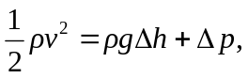 or

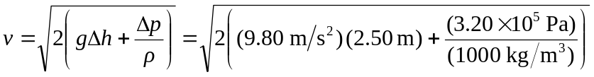
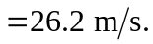

b) Let 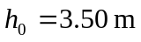 and 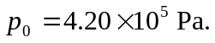 In the above expression for 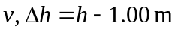 and 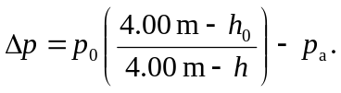 Repeating the calculation for 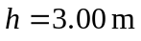 gives 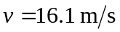 and with 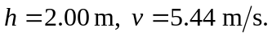 c) Setting 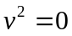 in the above expression gives a quadratic equation in h which may be re-expressed as

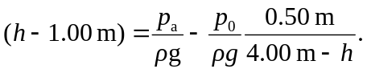

Denoting 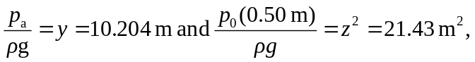 this quadratic becomes

which has as its solutions 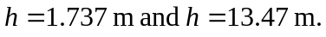 The larger solution is unphysical (the height is greater than the height of the tank), and so the flow stops when 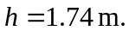

Although use of the quadratic formula is correct, for this problem it is more efficient for those with programmable calculators to find the solution to the quadratic by iteration. Using 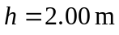 (the lower height in part (b)) gives convergence to three figures after four iterations. (The larger root is not obtained by a convergent iteration.)

